**Structure Query Language “SQL”**

Database:

MSACCESS – front end and back end

SQL Server – Backend

ORACLE – Backend Database

SYBASE – Backend

DB2 –Backend

Select Salary

From Employees

Where Name = Ankur

**Result**:

Salary

1000

Select Name, Salary. SSN

From Employees

Where Employee # = 001

Name Ankur

Salary 1000

Select Employee #. Name, Salary, SSN

From: Employee

Where: Employee = 001

**Result:**

Name Ankur

Salary 1000

SSN: 100-10-1000

Employee #: 001

**Select \***

From Employees:

Where: Name = Ankur

OR

Where Employee #: 001

**Result:**

Name Ankur

Salary 1000

SSN: 100-10-1000

Employee #: 001

DOB: 08/12/1990

**Select \***

From Employees:

Result:

Name:

Salary:

SSN:

DOB:

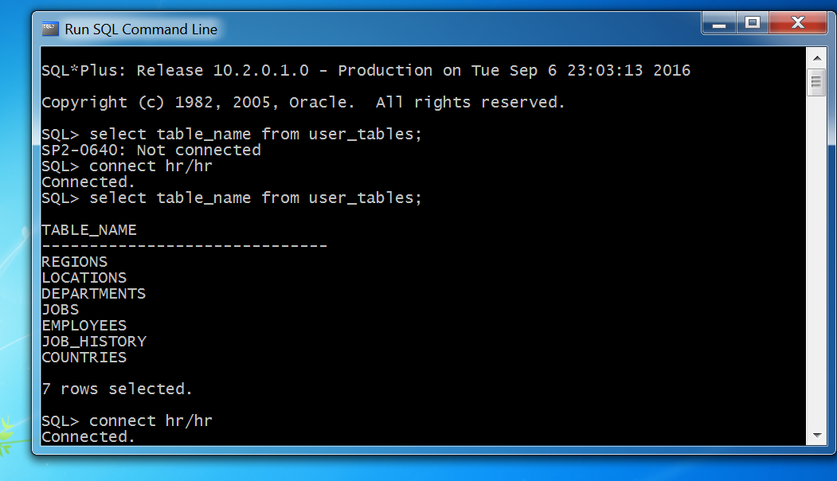

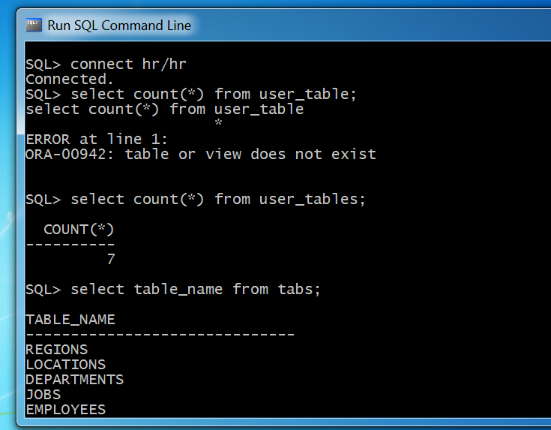

1. Connect hr/hr
2. Select table_name from user_tables;
3. Select table_name from tabs;
4. Select count(*) from user_tables;
5. Select * from employees;

SQL Config: right click on blue bar and click on property

Select Font:

Size 20

Select Layout:

Width: 400

Height: 9000

1. Set linesize 400;
2. Set pagesize 400;
3. Select * from employees:
4. Spool c:/sqllab01012020.doc **Note: Creating document**
5. **Edit and then save it**
6. **Ed**
7. Select * from employees

Where employee_id=111;

/

then close and save it.

1. **Ed**
2. Select * from employees

Where employee_id=111

/

1. **/**
2. Select * from employees

Where first_name=’John’

1. Select * from employees

Where upper (last_name)=’CHEN’

1. Select * from employees

Where upper (first_name)=’**JOHN’**

1. Select * from employees

Where lower (first_name)=**’john’**

1. Select * from employees

Where initcap (first_name)=’**J**ohn’

1. Select * from employees

Order by first_name

1. Select * from employees

Order by last_name

1. Select * from employees

Where upper (first_name)= ‘John’

and

upper (last_name)=’Chen’

1. Select * from employees

Where upper (first_name)= ‘John’

and

upper (last_name)=’Chen’ **Should be in Capital**

1. Select * from employees

WHERE UPPER(FIRST_NAME)= ‘JOHN’

OR

UPPER(LAST_NAME)=’BULL’

1. select * from employees

where UPPER(FIRST_NAME)='JOHN'

OR

UPPER(LAST_NAME)='CHEN'

1. SELECT * FROM EMPLOYEES

WHERE UPPER(FIRST_NAME) LIKE 'A%'

1. **Write a query to retrieve employees name, salary and commission**
2. SELECT * FROM EMPLOYEES

Ed

select first_name, last_name, salary,commission_pct

from Employees

/

1. **Find out those employees who have commission?**

select first_name, last_name, commission_pct

from Employees

where commission_pct is not null

1. select first_name, commission_pct

from employees

where commission_pct is null

1. **Find out those employees who get more than average salary**

select avg(salary)

From employees Note: For finding average salary

**select First_name, last_name**

**From employees**

**where salary>6461.68224**

1. select First_name, last_name, salary

From employees

where salary>(Select AVG(salary)

From employees)

1. select Employee_ID, First_name, last_name, salary

From employees

where salary>(Select AVG(salary)

From employees)

1. **Find out those employees who get the same salary as Peter Tucker**

**select first_name, last_name, salary**

**from employees**

**where upper (first_name)='PETER'**

**and**

**Upper (last_name)='TUCKER'**

**/**

1. select first_name, last_name, salary

from employees

where salary=10000

1. select first_name, last_name, salary

from employees

where salary =(select salary

from employees

where upper(First_name)='PETER'

and

upper(last_name)='TUCKER')

/

1. Find out who earns the maximum salary

select max(salary)

from employees

Result: 24000

1. select first_name, last_name

from employees

where salary=24000

1. select first_name, last_name

from employees

where salary=(select max (Salary) from employees)

1. **Write a query to retrieve/ to display first 10 records from a table**

**select * from employees**

**Where rownum in (1,2,3,4,5,6,7,8,9,10)**

1. select * from employees

where employee _ID between 100 and 109

1. select * from employees

where

rownum between 1 and 10

1. select * from employees

where rownum<11

1. Find out the row number 11 to 20 from a table

(Select * from employees

where rownum<21)

Minus

(select * from employees

where rownum<11)

1. (Select * from employees

where rownum<=20)

Minus

(select * from employees

where rownum<10)

SELECT E.FIRST_NAME,E.LAST_NAME,E.SALARY,D.DEPARTMENT_NAME, L.CITY, C.COUNTRY_NAME,

R.REGION_NAME,JH.START_DATE,J.JOB_TITLE

FROM

EMPLOYEES E, DEPARTMENTS D, LOCATIONS L,

COUNTRIES C, REGIONS R, JOB_HISTORY JH, JOBS J

WHERE

E.DEPARTMENT_ID = D.DEPARTMENT_ID

AND

D.LOCATION_ID=L.LOCATION_ID

AND

L.COUNTRY_ID=C.COUNTRY_ID

AND

C.REGION_ID=R.REGION_ID

AND

JH.DEPARTMENT_ID=D.DEPARTMENT_ID

AND

JH.JOB_ID = J.JOB_ID

Data Type in Java

1)

premitive data type where you will user all the bellow data types

int, char, short, boolean, double, lang, etc....

2) Derived Data type

array, arraylist, string, hashmap, etc......\

[http://38.100.142.131/etc/apps/phpmyadmin](http://38.100.142.131/etc/apps/phpmyadmin/)

<http://38.100.142.131/etc/apps/phpmyadmin/>

<http://forumlab.piit.us/>